- Walking-Standing-Laying (labels [1,5,6])

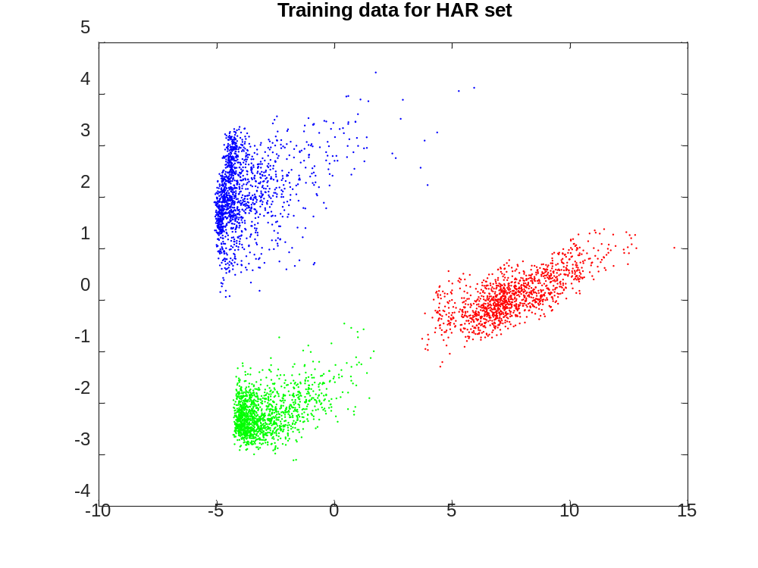
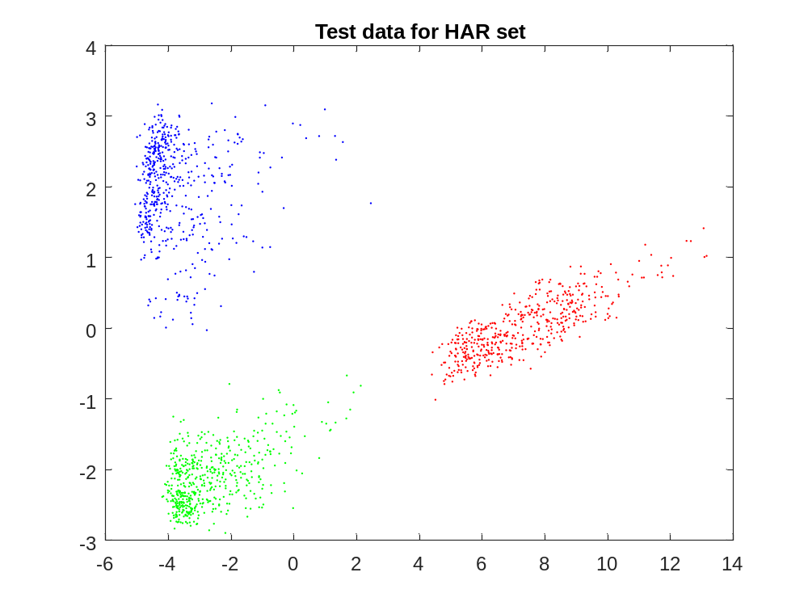
Walking-Sitting-Laying (labels [1,4,6])
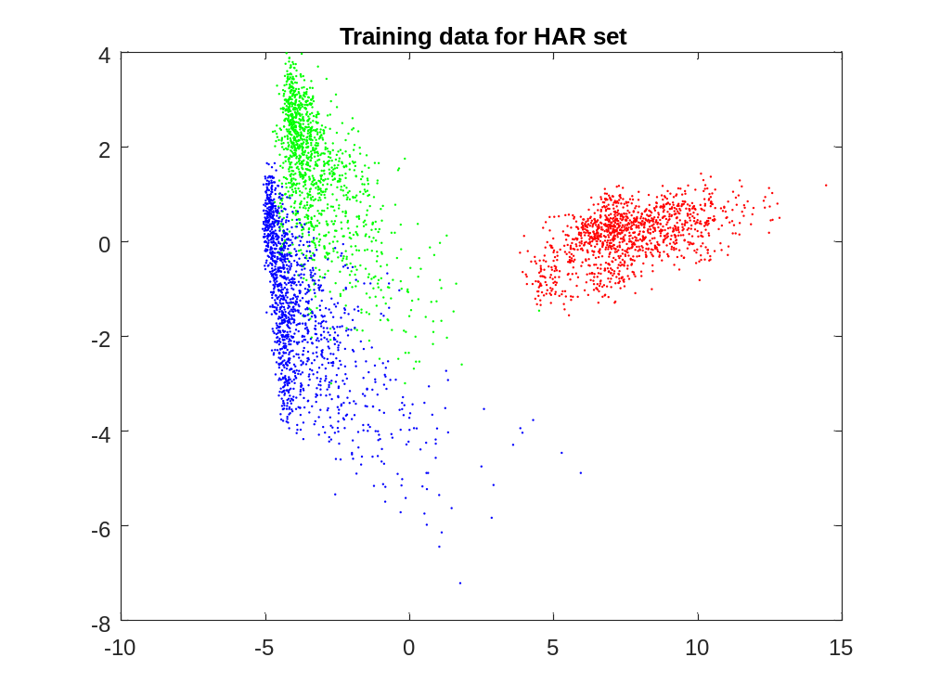
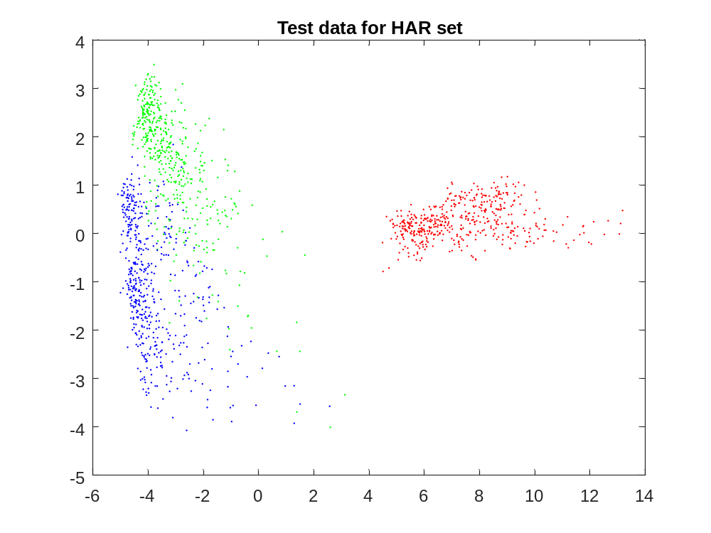
- The 100th training data is (8.3982,-0.24179), and its label is 1.
The 100th testing data is (-3.5846,-2.2109), and its label is 5.

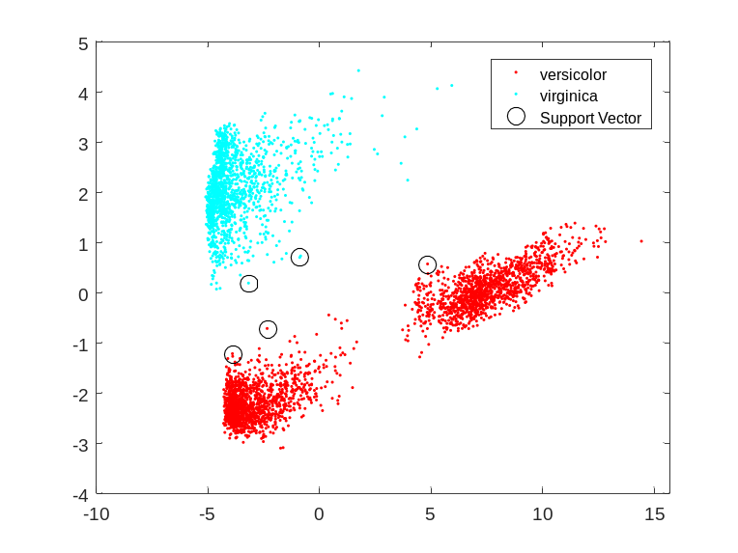
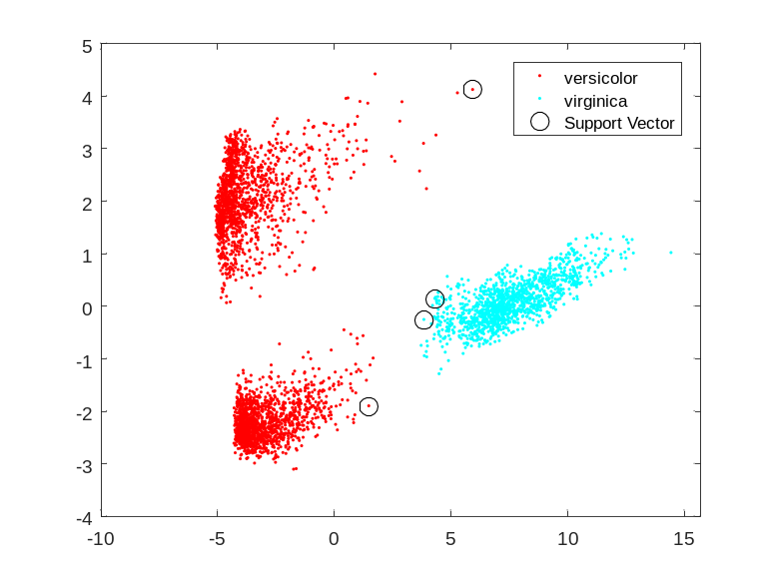
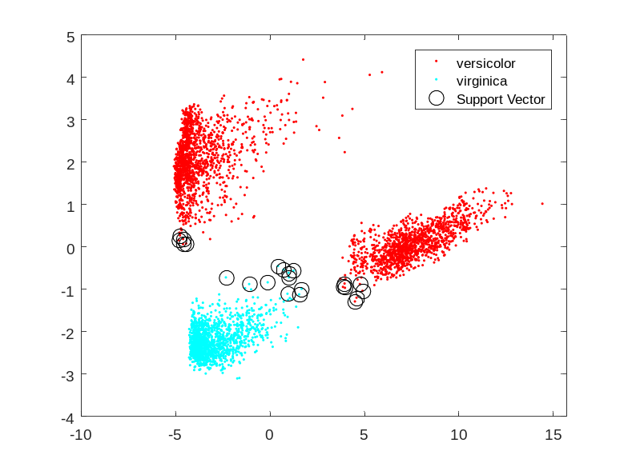
- The boundary of walking-laying to standing might change, since the point (-4,1) is near the boundary of it as shown in the image. Comparing to some of the other supporting point, it can probably make the margin smaller. (the green triangle is the added point)
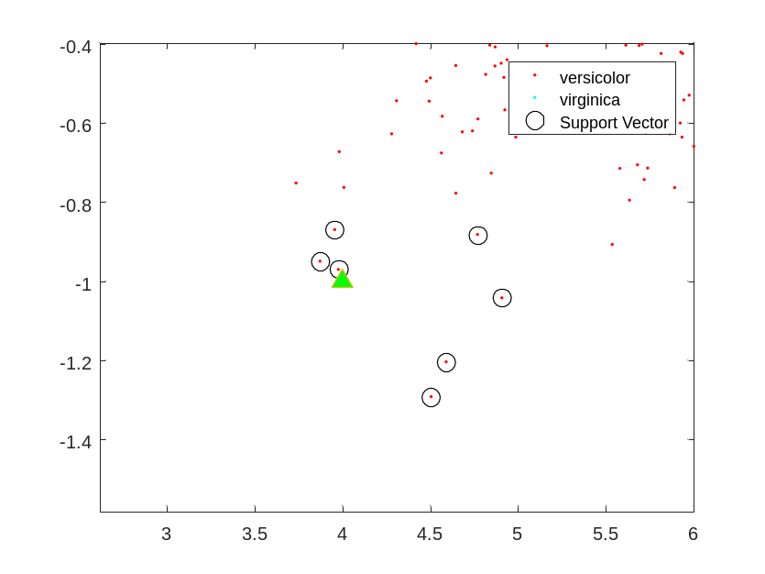
After adding data (4,-1) and zoom in to the same place,
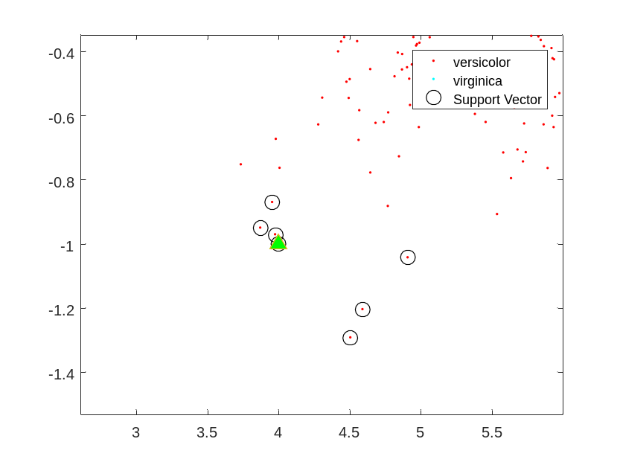
Now we find out a new support vector is generated on data point (4,-1) and an old one is replaced.

- The confusion matrix:
C = 496 0 0
0 532 0
0 0 537
Here we can see the confusion matrix is a diagonal matrix, which means the accuracy is 100%.

- 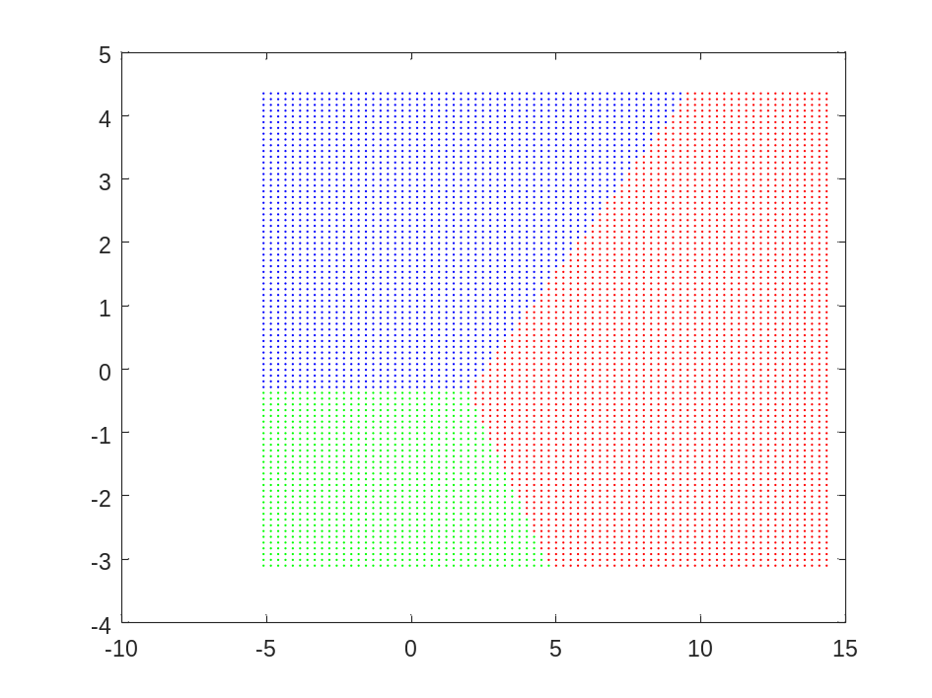
- Confusion matrix:
496 0 0
2 455 34
0 47 490
